**College of Engineering**

**Department of Systems Engineering**

**Final Report**

**Structural health monitoring for civil infrastructure using artificial intelligence and digital twin**

|  |  |
| --- | --- |
| Student name: | Zhang Peining |
| Student ID: | 57124831 |
| Major: | Intelligent Manufacturing (ITME) |
| Department: | SYE |
| Project supervisor: | Liu Cheng |
| Submission date: | 05 / 04 / 2025 |

# 

## Student Final Year Project Declaration

I have read the student handbook and I understand the meaning of academic dishonesty, plagiarism and collusion. I declare that the work submitted for the final year project does not involve academic dishonesty. I give permission for my final year project work to be electronically scanned and if found to involve academic dishonesty, I am aware of the consequences as stated in the Student Handbook.

|  |  |
| --- | --- |
| Student name: | Zhang Peining |
| Student ID: | 57124831 |
| Major: | Intelligent Manufacturing (ITME) |

## Abstract

While Digital Twin technology holds great promise for advancing Structural Health Monitoring (SHM), challenges such as environmental noise, measurement errors, and computational constraints often limit its accuracy and real-time applicability. To address these limitations, this study proposes two hybrid deep learning architectures—1D CNN-LSTM and 1D CNN-Transformer—to detect defects in a numerical bridge model generated using Digital Twin simulations. Bayesian optimization is further employed to enhance damage detection accuracy, mitigate overfitting, and enable cost-effective, proactive maintenance strategies.

## Acknowledgements

(Insert contents)

## Table of Contents

Student Final Year Project Declaration 1

Abstract 2

Acknowledgements 3

Table of Contents 4

Chapter 1: Introduction 5

1.1. Background 5

1.2. Aims and Objectives 6

Chapter 2: Literature Review 6

2.1. Global Methods in SHM 6

2.1.1. Data-Driven Methods 7

2.1.2. Physics model-based methods 7

2.1.3. Hybrid Techniques 8

2.2. Local Methods in SHM 8

2.2.1. Non-Destructive Testing Techniques 8

2.2.2. Enhancing Local Methods with Deep Learning 9

Chapter 3: Research Methodology 9

3.1. Data from DT bridge model 9

3.2. 1-D CNN and LSTM 11

3.3. 1-D CNN and Transformers 14

3.4. Tree-structured Parzen Estimator 16

Chapter 4: Experiment Results 16

4.1. Training CNN-LSTM and CNN-Transformer Before Bayesian Optimization 16

4.2. TPE Optimization for CNN-LSTM and CNN-Transformer 19

Chapter 5: Conclusion 23

References 23

Appendix 27

## Chapter 1: Introduction

### **Background**

Structural Health Monitoring (SHM) has emerged as a pivotal domain within civil engineering, aimed at the early detection of structural defects, real-time monitoring of infrastructure conditions, and the assessment of structural safety. With the aging of infrastructure and increasing environmental challenges, SHM systems are indispensable for ensuring the operational integrity of critical assets, such as bridges, buildings, and dams. By leveraging data collected from a variety of sensors, SHM systems continuously or periodically assess structural conditions, ensuring resilience against external forces and supporting long-term functionality. The integration of advanced monitoring technologies provides a comprehensive view of structural health, offering a reliable foundation for condition-based maintenance strategies[1]. Civil infrastructure, including bridges, dams, and tunnels, represents critical assets that underpin societal functioning. However, these structures are constantly subjected to dynamic loads, environmental stressors, and natural aging processes, which contribute to progressive deterioration[12]. Structural degradation, if undetected, can compromise safety, disrupt operations, and increase the risk of catastrophic failures. Traditional maintenance practices, such as periodic visual inspections and scheduled repairs, have inherent limitations due to their inability to detect concealed damage, high costs, and susceptibility to human error. SHM systems address these challenges by providing continuous, real-time monitoring, ensuring structural integrity, and enhancing maintenance strategies[34][35][36].

One of the critical advantages of SHM lies in its ability to detect early signs of damage, thereby reducing the likelihood of catastrophic failures and extending the lifespan of infrastructure[2]. By collecting real-time data from sensors such as accelerometers, strain gauges, and displacement transducers, SHM systems continuously monitor a structure’s behavior and compare it to baseline conditions. Significant deviations from baseline behavior trigger alarms, enabling early diagnosis and preventive maintenance. This proactive approach optimizes maintenance schedules, minimizes operational downtime, and lowers repair costs. Moreover, SHM aligns with sustainability goals by reducing the need for frequent physical inspections and lowering the overall environmental impact of infrastructure maintenance. These systems conserve resources by minimizing physical assessments while providing accurate and reliable data. Additionally, SHM systems play a critical role in ensuring the safety of infrastructure during extreme conditions, such as earthquakes, floods, or high winds, where real-time monitoring is essential for protecting both the structure and its users.

Despite its advantages, traditional SHM methods face several challenges that limit their effectiveness. One major challenge is the vast volume of data generated by modern SHM systems[5]. The extensive sensor networks embedded in structures produce immense datasets, which require efficient processing and analysis to identify potential damage. Traditional techniques often struggle with handling such large datasets and rely heavily on manual intervention, introducing delays, errors, and inefficiencies[3]. Moreover, current SHM systems frequently encounter difficulties in real-time data analysis, hampering timely damage detection and diagnosis. Another critical challenge lies in the complexity and variability of structural behaviors. Structures exhibit unique dynamic responses influenced by factors such as environmental conditions and loading scenarios, making it difficult to detect anomalies without in-depth knowledge of these variables[5]. Additionally, in some cases, SHM systems still require manual inspections to validate automated analysis results, adding further complexity and cost to the maintenance process.

To overcome these challenges, the integration of Digital Twin (DT) technology into SHM represents a transformative advancement. A DT is a virtual replica of a physical asset that evolves alongside its real-world counterpart by integrating real-time sensor data and simulations[3]. In SHM, DTs enhance monitoring capabilities by merging data-driven insights with physics-based models, offering a comprehensive and dynamic representation of structural behavior. During the design phase, DTs enable virtual simulations to predict structural performance under various conditions, facilitating optimal designs prior to construction. In the operational phase, DTs continuously assimilate real-time data from embedded sensors, enabling real-time monitoring, fault diagnosis, and predictive maintenance. This approach not only improves structural reliability and safety but also reduces the frequency of physical inspections, resulting in more cost-effective maintenance. Furthermore, the application of deep learning has the potential to revolutionize SHM by providing sophisticated data analysis techniques capable of handling large datasets and detecting complex patterns in structural behavior[9]. Traditional methods, which often rely on statistical models and rule-based algorithms, struggle to identify subtle or evolving damage. In contrast, deep learning techniques, including Convolutional Neural Networks (CNNs), Recurrent Neural Networks (RNNs), and Transformer-based models, excel in time-series analysis. These models can effectively learn temporal patterns associated with structural changes, enabling automated anomaly detection in real time[10].

### **Aims and Objectives**

This research aims to develop an advanced SHM framework by integrating DT technology with hybrid deep learning architectures to enhance the accuracy, efficiency, and scalability of structural damage detection and classification. The study begins by creating high-fidelity DT models of bridge structures through finite element simulations, generating synthetic vibration datasets that account for diverse operational conditions and damage scenarios. Building on this foundation, hybrid deep learning models—1D CNNs with LSTM and 1D CNNs with Transformer—are designed to capture spatial-temporal features and long-range dependencies in vibration signals. To refine these models, Bayesian optimization via the Tree-structured Parzen Estimator (TPE) is employed to mitigate overfitting, improve generalizability, and identify the most valuable sensor nodes for targeted data training. By focusing on these critical nodes, the framework enables more efficient and rapid damage diagnosis. The efficacy of the proposed approach is rigorously validated using performance metrics such as accuracy, precision, recall, and F1-score. Through a comparative analysis of the CNN-LSTM and CNN-Transformer models, the study demonstrates the CNN-LSTM’s superiority in long-sequence analysis while establishing a scalable, resource-efficient workflow. This work contributes a novel integration of DT simulations with deep learning for automated, real-time SHM, ultimately advancing infrastructure resilience against deterioration and catastrophic failures.

## Chapter 2: Literature Review

SHM methodologies are broadly categorized into Global Methods and Local Methods, each offering distinct approaches tailored to specific monitoring needs. Recent technological advancements, particularly in DT and deep learning, have considerably augmented both categories, enabling enhanced precision and efficiency in monitoring capabilities[1].



### **Global Methods in SHM**

Global SHM methods aim to detect changes in a structure's overall behavior by analyzing its dynamic characteristics, such as natural frequencies, damping ratios, and mode shapes. These vibration-based techniques utilize data collected from sensors that monitor the structural response to external forces, effectively identifying damage that impacts structural integrity. These methods are typically categorized into data-driven approaches, physics-based models, and hybrid techniques. The advent of DT technology has transformed global SHM by enabling real-time simulations that continuously update using sensor data. When integrated with advanced deep learning models, such as Transformers, DTs enhance the system's ability to process time-series data for detecting anomalies and predicting potential failures[2][3][4].

#### 

#### **Data-Driven Methods**

Statistical and machine learning techniques play a key role in identifying patterns and anomalies in collected SHM data. Methods such as Principal Component Analysis (PCA), Support Vector Machines (SVMs), and neural networks are widely used to process vibration data for damage detection. Deep learning models, including CNNs, Long Short-Term Memory (LSTM) networks, and Transformers, have significantly advanced data-driven SHM methods. These models excel at extracting hierarchical features and capturing long-range dependencies in structural vibration data, enabling efficient processing of large datasets and real-time damage identification[1][7][13]. For examples, Wang and Cha[17] proposed an unsupervised learning approach using acceleration signals from a laboratory-scale 3D steel bridge. They normalized the response signal vectors and applied Continuous Wavelet Transformation (CWT) and Fast Fourier Transformation (FFT). The transformed data were processed by a two-dimensional (2D) CNN autoencoder to extract key features, while One-Class Support Vector Machines (OC-SVMs) served as novelty detectors for each sensor, helping locate loose-bolt damage based on the highest novelty rates. Similarly, Abdeljaber et al.[13] developed a damage detection framework utilizing output-only acceleration data. They created training datasets for various simulated damage scenarios, such as loose bolts, and trained individual CNNs for each case. The resulting Probability of Damage (PoD) indicator achieved high accuracy with an average error of 0.54% across different damage scenarios. However, practical applications face challenges due to large data requirements for varied damage permutations, as highlighted by Abdeljaber et al.[14]. To address this, a simplified approach was proposed[15], requiring only two damage states—undamaged and fully damaged—though this method provided only a general assessment of structural conditions. Despite the advancements in deep learning-based SHM, current methodologies still struggle to achieve full automation. Replicating human perception through vibration- or vision-based deep learning algorithms remains a significant challenge[18].

#### **Physics model-based methods**

Accurate mathematical models are essential for post-processing measured data to predict damage location and severity. Commonly used models include finite difference methods (FDM), finite element methods (FEM), spectral finite element methods (SFEM), and boundary element methods (BEM)[19]. Among these, Finite Element Models (FEMs) are particularly prevalent for simulating the mechanical behavior of structures under various loading conditions[11][12][37][38][39][40]. In SHM studies, a critical aspect of using FEM is the precise modeling of damage, such as cracks. Researchers have developed diverse techniques to simulate defects within the FEM framework. For example, Powar and Ganguli[22] used FEM to model matrix cracks in composite beams, which facilitated the assessment of the performance of a rotating helicopter blade. Similarly, Yang et al.[23] applied FEM to study Lamb wave propagation in composite plates, demonstrating its effectiveness in wave-based damage detection. Crack parameters were also successfully extracted in a study utilizing FEM analysis[20]. Moreover, a novel method employing the Heaviside function was introduced for crack modeling within the FEM framework, offering an innovative approach to damage representation[21].

#### **Hybrid Techniques**

The integration of data-driven models with physics-based approaches has gained significant traction, as hybrid methods enhance the robustness and accuracy of damage detection. These approaches combine simulation outputs with real-time sensor data to improve predictive performance. For example, FEM-based models can generate baseline predictions, while deep learning algorithms refine these predictions using feedback from sensors. Lin et al.[16] explored the application of a CNN trained on simulated FEM data of a simply supported beam, considering both noisy and noise-free environments. Their study demonstrated that critical structural features, such as response frequency bands, vibration modes, and their interactions, could be effectively captured by the CNN using sensor data. Additionally, a novel framework called DeepSHM was developed, leveraging data augmentation of sensor signal responses obtained from FEM simulations. This framework provides a generalized methodology by feeding augmented data into a CNN for training, enabling the extraction of neural weights[24].

### **Local Methods in SHM**

Local SHM methods focus on specific components or areas of a structure to identify and evaluate damage. These techniques often involve detailed assessments or Non-Destructive Testing (NDT) methods to detect localized issues, such as cracks, corrosion, or material degradation. Unlike global SHM methods, local approaches are highly targeted, frequently leveraging insights from global analyses to pinpoint potential damage zones. DT technology enhances local SHM by providing precise simulations of localized damage. DTs utilize real-time data integrated with multi-physics finite element models (FEM) to analyze stress, strain, and displacement in critical areas. For instance, a DT can simulate interactions between piezoelectric sensors and the structure to identify micro-cracks in real time[13]. By combining DT technology with deep learning, local SHM methods gain improved interpretability and accuracy, supporting targeted repair strategies and reducing inspection expenses.

#### **Non-Destructive Testing Techniques**

Traditional NDT techniques, such as ultrasonic testing and thermography, are integral to local SHM[41][42][43][44][45]. Ultrasonic Testin uses high-frequency sound waves to identify subsurface defects like cracks and voids. Ultrasonic guided waves (UGWs) are widely applied in health prognosis through various probing techniques, including contact, semi-contact, and non-contact approaches. In the contact method, acoustic sensors—often bonded to or embedded within structural surfaces—are employed to excite and detect acoustic waves[25]. These sensors are crafted from materials responsive to electrical or magnetic stimuli, generating strain upon excitation. Common transducer materials include piezoelectric polymers (PVDF), piezoelectric ceramics (PZT), electrostrictive ceramics (PMN), and magnetostrictive materials (Terfenol-D). Thermograph employs infrared imaging to detect temperature variations that indicate structural damage. Miao et al.[26] introduced an innovative electromagnetic thermography approach for subsurface defect detection. By leveraging radiation parameters and the thermophysical properties of the medium, this method demonstrated superior performance in identifying natural subsurface cracks.

#### **Enhancing Local Methods with Deep Learning**

Deep learning has significantly enhanced the efficiency and precision of local SHM methods. CNNs are widely used to process image-based NDT data, such as radiographic or thermographic images, enabling automated defect classification. Transformer-based Models excel in capturing contextual relationships within complex datasets, further improving the accuracy of defect identification and localization. By reducing the dependence on manual inspections, these advancements enhance the scalability of local SHM techniques. For example, Ali and Cha[27] developed a method combining passive thermography with a Deep Inception Neural Network (DINN) to identify and localize internal defects in steel bridge components. Arbaoui et al.[28] applied CNN architectures, including AlexNet and ResNet50, to detect cracks in concrete structures by integrating ultrasonic testing with multiresolution analysis. Han et al.[29] proposed a 2D CNN model to detect crack signals in concrete structures using acoustic emission data.

## Chapter 3: Research Methodology

In this project, a large set of numerical models simulating real bridge structures was created using Digital Twin (DT) technology. These models were then used to train two hybrid architectures: CNN-LSTM and CNN-Transformer. A portion of the simulated data was used to fine-tune the models via Bayesian Optimization, focusing on hyperparameter optimization. The remaining data was reserved for evaluating model performance. The implementation process is illustrated in Fig. 1.

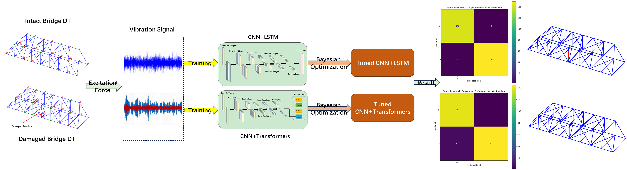

Fig. 1. Overview of method implementation.



### **Data from DT bridge model**

In this project, two numerical bridge models—one healthy and one damaged—were established using DT technology. The dimensions of the models are as follows: length = 2.4 m, width = 0.3 m, and height = 0.3 m. The modeling parameters for these numerical bridge models are provided in Table 1. The four random factors used in the numerical modeling were set as follows (based on the ABAQUS platform, SIMULIA Inc., Providence, RI, USA):

1. The numerical models were randomly scaled by ±15% from a physical bridge model, as outlined in[10].
2. A 1000 N excitation force was applied through random amplitude curves along the y-axis. The excitation point was randomly selected from one of the 32 points in the healthy truss model (green points in Fig. 2) and 34 points in the damaged truss model (green points in Fig. 3).
3. The random excitation forces were generated using the "randbetween" function in Excel, with a total of 34 values applied to nodes in both models.
4. The excitation force was applied for 4 seconds on each node, and acceleration data in the x, y, and z directions were collected. The time step for data collection was 0.002 seconds, resulting in 2001 data points for each node.

Fig. 2 and Fig. 3 illustrate the sampling point locations in the numerical models, with 32 points in the healthy model and 34 in the damaged model. However, after visualizing the collected data, it was observed that certain data points could potentially mislead the model’s predictions. These points were manually removed, though further work is required to identify and eliminate additional misleading data, as discussed in Chapter 4.

For the healthy model, 27 nodes were retained as valid data points. When a random excitation force was applied to a single node, vibration signals were collected from all 27 nodes. After iterating this process across all 27 nodes, a total of 27x27 sets of healthy data were collected, each with dimensions (2001, 1), where 2001 corresponds to the number of time steps, and 1 represents the vibration signals in the y direction. Similarly, for the damaged model (with flat steel bars damaged between nodes 20 and 24), the same 27 nodes were selected, yielding 27x27 sets of damaged data, each with a size of (2001, 1). Consequently, the final dataset size is (2x27x27, 2001, 1).

Table 1. The modelling parameters by ABAQUS.

|  |  |  |  |  |
| --- | --- | --- | --- | --- |
| Elastic modulus | Poisson’s ratio | Mass density | Modal damping ratio | Meshed with |
| 210 | 0.3 | 7,8000 | 0.03 | Beam elements  (B31 type) |

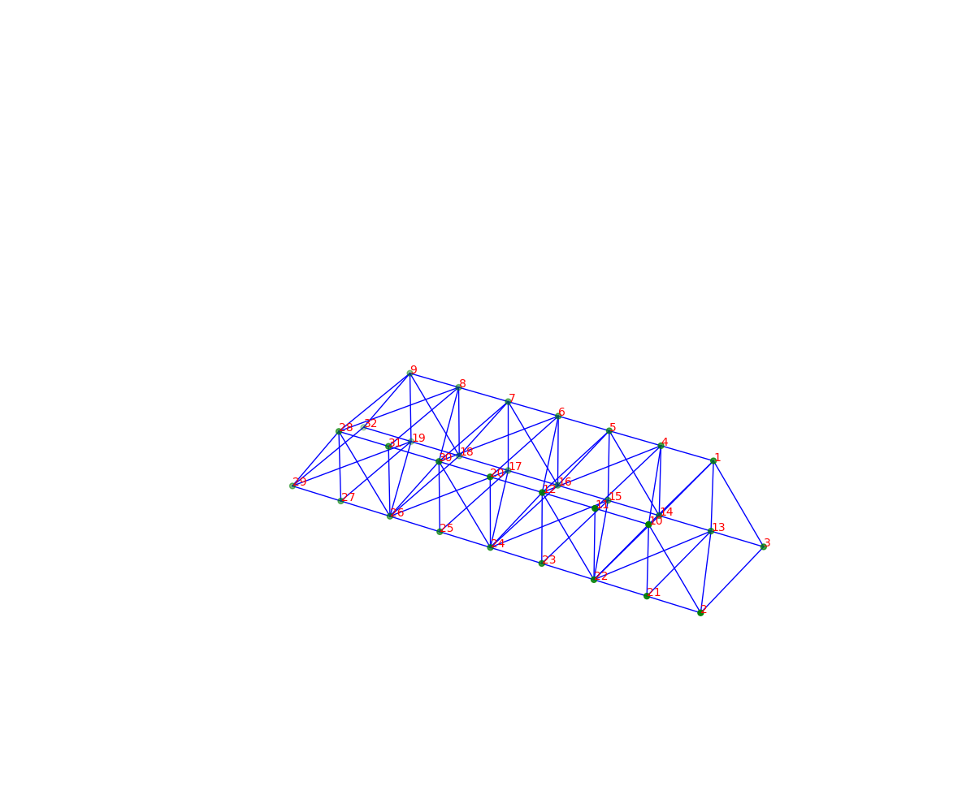

Fig. 2. Layout of the health truss model.

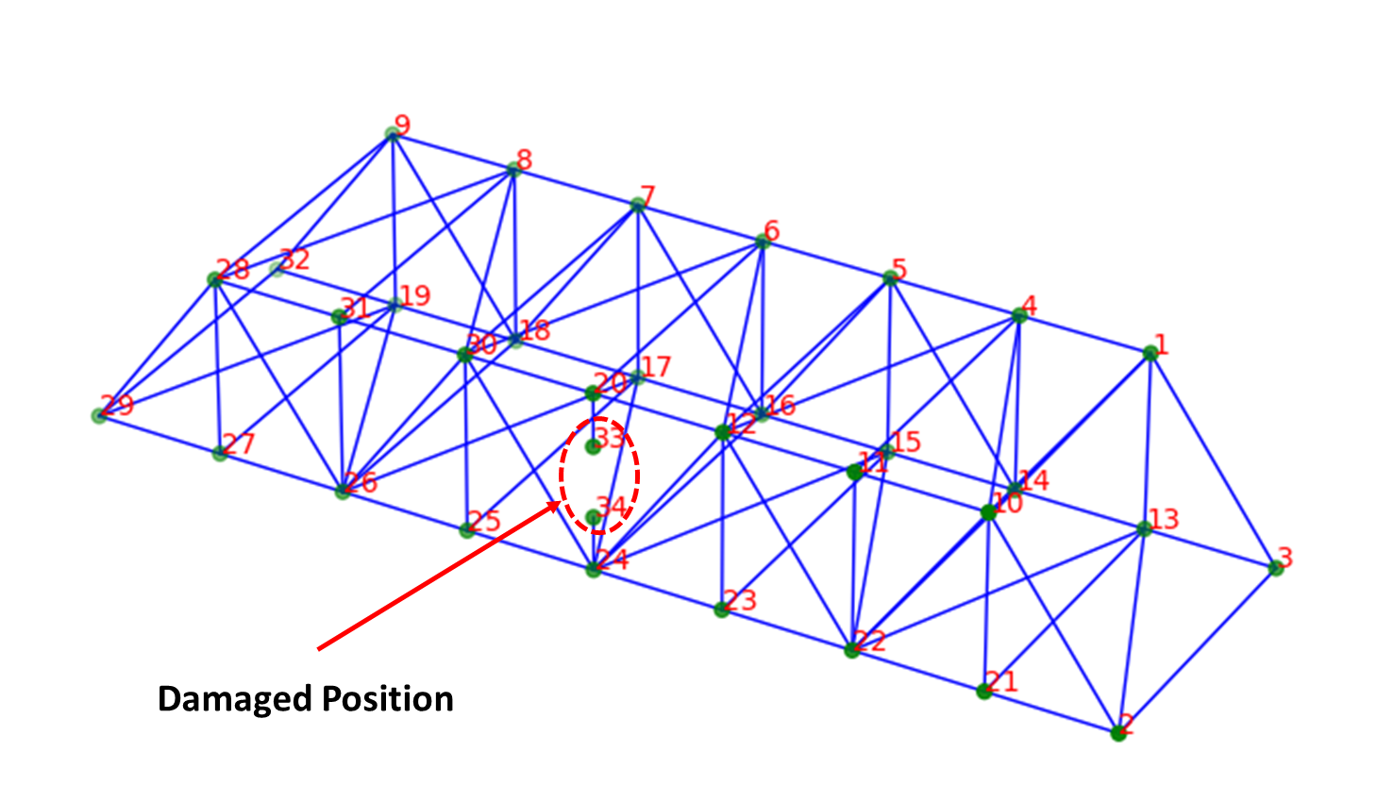

Fig. 3. Layout of the damaged truss model.

### **1-D CNN and LSTM**

One-Dimensional Convolutional Neural Networks (1D CNNs) are a specialized form of traditional 2D CNNs, designed for processing sequential or one-dimensional data. A key advantage of 1D CNNs is their computational efficiency, with a complexity of O(NK) compared to O(N²K²) for 2D CNNs of equivalent dimensions[30]. Typically, 1D CNNs use more compact architectures, featuring 1-2 hidden layers and fewer than 10K parameters, in contrast to 2D CNNs, which often require millions of parameters. The structure of a 1D CNN is shown in Fig. 4. This streamlined design makes 1D CNNs particularly suitable for real-time applications and resource-constrained environments, as they can be trained and deployed on standard CPUs without the need for specialized hardware like GPU farms. Their applications extend across various fields, including signal processing, sensor data analysis, time series forecasting, and mobile computing. The combination of reduced computational requirements, simpler implementation, and effective performance makes 1D CNNs ideal for mobile devices, IoT applications, and other scenarios that require processing efficiency and real-time performance[31].

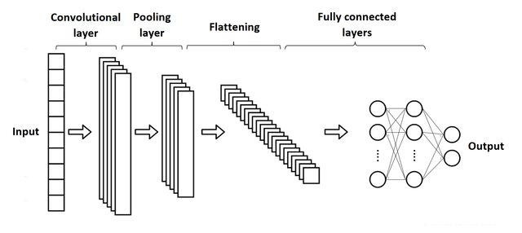

Fig. 4. The structure of 1-D CNN[32].

CNN architecture is based on two primary components: convolution and pooling layers. In a 1D CNN, the convolution operation for single-channel data can be mathematically represented as:[33]

This operation involves the filter sliding across the input signal, computing the sum of element-wise multiplications between the filter coefficients and the corresponding input values at each position. For multi-channel data, the convolution operation is applied simultaneously across all channels, with the results being aggregated. The movement of the filter across the input is controlled by the stride parameter, which defines the step size between consecutive filter positions. Following the convolution layer, a pooling layer is generally applied to reduce the dimensionality of the feature maps while retaining important information. Max pooling is a common approach, which halves the feature map size by selecting the maximum value within each pooling window. To introduce non-linearity, activation functions like the Rectified Linear Unit (ReLU) are used. ReLU is effective due to its computational efficiency and its ability to mitigate the vanishing gradient problem. The ReLU function is defined as:

where is the input value.

LSTM networks are built around specialized memory units called cells. Each cell manages both a cell state and a hidden state, which propagate through the network. The cell state serves as the main information pathway, allowing data to flow with minimal modification through controlled gates. The structure of the LSTM used in this study is shown in Fig. 5.

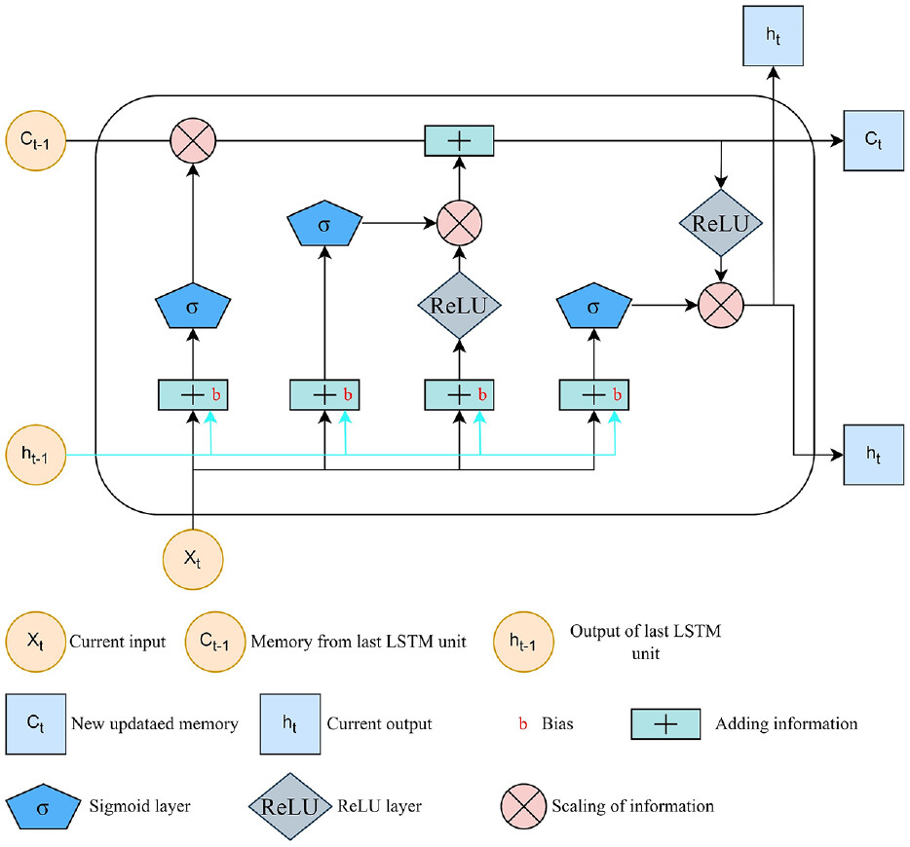

Fig. 5. The structure of LSTM[32].

LSTM operation involves three main phases: First, the forget gate:

determines which information should be discarded from the previous state. The second phase is the memory update, which combines an input gate:

with candidate values:

to update the cell state:

The final phase generates the cell’s output via the output gate:

and the final computation:

While traditional LSTMs typically use the tanh activation function, this architecture utilizes ReLU, which provides advantages such as improved handling of long-term dependencies, reduced vanishing gradient issues, faster convergence during training, and lower computational overhead. These benefits ultimately enhance the network's performance in sequential data processing tasks.

In this project, the 1-D CNN-LSTM model was employed to classify the damage scenarios of the bridge model. The structure of the 1-D CNN-LSTM network, as depicted in Fig. 6, consisted of four convolutional layers, two pooling layers, two LSTM layers, and one fully connected layer. The collected vibration signals (acceleration) served as the input to the model, while the damage scenarios of the bridge model were used as the output, with intact structures labeled as 0 and damaged structures labeled as 1. To preprocess the data, the acceleration signals in direction was normalized using standardization, ensuring that it had a mean of 0 and a standard deviation of 1. The dataset was split into training, validation, and test sets with proportions of 60%, 20%, and 20%, respectively. The model was trained using the Adam optimizer with an initial learning rate of 0.001 and a batch size of 32. Cross-Entropy Loss was employed as the loss function to calculate the difference between the predicted logits and the true labels. A learning rate scheduler, ReduceLROnPlateau, monitored the validation loss during training and reduced the learning rate by a factor of 0.5 if no improvement was observed for 5 consecutive epochs. The training process involved processing the normalized vibration data through the 1-D CNN layers to extract spatial features, followed by the LSTM layers to capture temporal dependencies. Finally, the output was passed through a fully connected layer to classify the scenarios into intact or damaged categories. This workflow facilitated effective classification of the bridge model's damage scenarios.

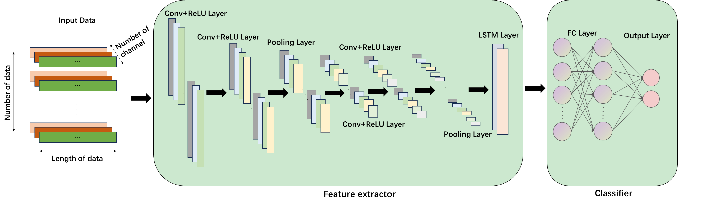

Fig. 6. Structure of the CNN-LSTM model.

### **1-D CNN and Transformers**

The 1-D CNN-Transformer model integrates the strengths of Convolutional Neural Networks (CNNs) in spatial feature extraction with the Transformer architecture’s capability in capturing long-range dependencies in sequential data. This hybrid architecture is particularly well-suited for structural health monitoring, where time-series vibration signals exhibit both local patterns and long-term temporal relationships. Transformers are deep learning models designed to handle sequential data without relying on recurrent structures. Instead of step-by-step processing, Transformers operate on entire sequences in parallel through an attention-based mechanism, significantly enhancing training efficiency and scalability.

The Transformer architecture, introduced by Vaswani et al. in 2017[34], has become a revolutionary model for sequence processing tasks by replacing recurrence with self-attention mechanisms, enabling parallelization and improved performance. The core components of the Transformer include Input Embedding and Positional Encoding, where positional encodings are added to input embeddings to preserve sequence order since Transformers process entire sequences at once. This is expressed as:

where represents the input embeddings and represents the positional encodings. The Multi-Head Self-Attention mechanism computes attention scores using the query , key , and value as:

This allows the model to focus on relevant parts of the sequence, with multi-head attention capturing different relationships in parallel:

Each attention head is computed as:

and is a learned output weight matrix. The Feedforward Network applies a position-wise fully connected network to the attention output, defined as:

where is the input, ​ and ​ are weight matrices, and ​ and ​ are bias terms. To improve training stability, Layer Normalization and Residual Connections are applied after each sub-layer:

where refers to either the self-attention or feedforward operation. Stacking Layers involves stacking multiple layers of self-attention and feedforward sub-layers, where the output of each layer is processed as:

The Transformer can include both an encoder and a decoder, but in many tasks like classification or regression, only the encoder is used. The advantages of the Transformer include parallelization, which allows for faster training compared to sequential models like RNNs, long-range dependency capture due to the self-attention mechanism, and scalability, making it highly effective for large datasets and complex models such as BERT and GPT. The model architecture is illustrated in Fig. 7.

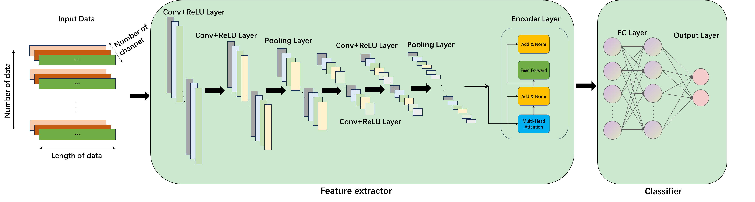

Fig. 7. Structure of the CNN-Transformer model.

### **Tree-structured Parzen Estimator**

The optimal architecture of the network was determined using Bayesian optimization. The Tree-structured Parzen Estimators (TPE), a robust hyperparameter optimization technique within the sequential model-based optimization (SMBO) framework, was employed to identify the most effective network configuration. Unlike conventional methods that directly model , TPE builds a probabilistic model by estimating and , where represents the hyperparameters and denotes the objective function value. The algorithm divides the observed performance metrics into two probability densities: for superior performances below a threshold (determined by the -quantile of observations) and for inferior performances. This relationship can be expressed as:

The optimization process maximizes the Expected Improvement (EI), defined as:

where represents the proportion of observations in . Both probability densities are modeled using Gaussian kernel density estimation, allowing for efficient handling of diverse hyperparameter types. The hierarchical structure and computational efficiency of this methodology made it particularly suitable for optimizing the network's architecture, with the final configuration chosen based on the minimum validation error.

## Chapter 4: Experiment Results

This section presents the results of the proposed methods for detecting defects in the bridge dataset and is divided into two parts: (1) a comparison between two different model structures—CNN+LSTM and CNN+Transformer—trained using the DT dataset, and (2) the application of a Bayesian optimization algorithm to identify both the optimal model structure and the eight most informative data nodes for training.

### **. Training CNN-LSTM and CNN-Transformer Before Bayesian Optimization**

Initially, training samples generated from the numerical models described in Section 3.1 (using DT technology) were used to train a basic 1D CNN-LSTM model. The training process utilized Y-axis vibration data. The training and validation results (including accuracy and loss values) are shown in Fig. 8. The best model achieved a validation loss of 0.1768 and 96.23% accuracy. When evaluated on test data, as shown in Fig. 9 and Table 2, it achieved 96.58% across accuracy, precision, and recall, with an F1 score of 96.57%, as indicated by the confusion matrix and evaluation metrics. These results demonstrate that CNN-LSTM is well-suited for time-series classification in this context.

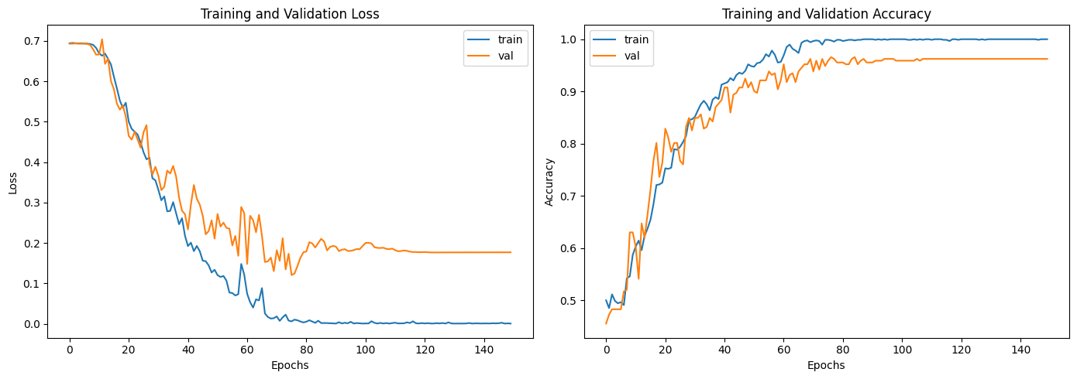

Fig. 8. Training and validation results for the basic CNN-LSTM.

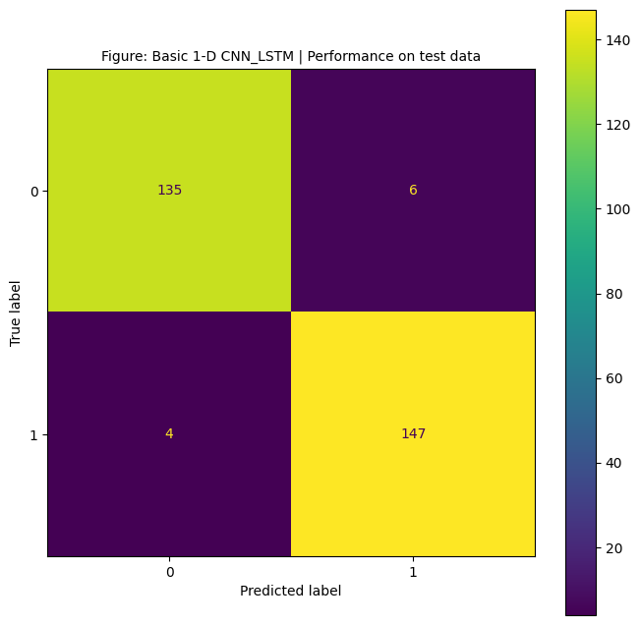

Fig. 9. Confusion matrix for test data using the basic CNN-LSTM.

Table 2. Evaluation metrics for the basic CNN-LSTM on test data.

|  |  |  |  |
| --- | --- | --- | --- |
| Accuracy | Precision | Recall | F1-Score |
|  |  |  |  |

Similarly, the CNN-Transformer model was trained on the same dataset. Training and validation results are shown in Fig. 10. The best model achieved a validation loss of 0.2585 and accuracy of 94.86%. On the test data shown in Fig. 11 and Table 3, the model achieved an accuracy of 91.44%, with a precision of 91.52%, recall of 91.44%, and F1 score of 91.43%. Although the CNN-Transformer performed well in detecting bridge defects, its performance was slightly worse and its training time significantly longer than that of CNN-LSTM.

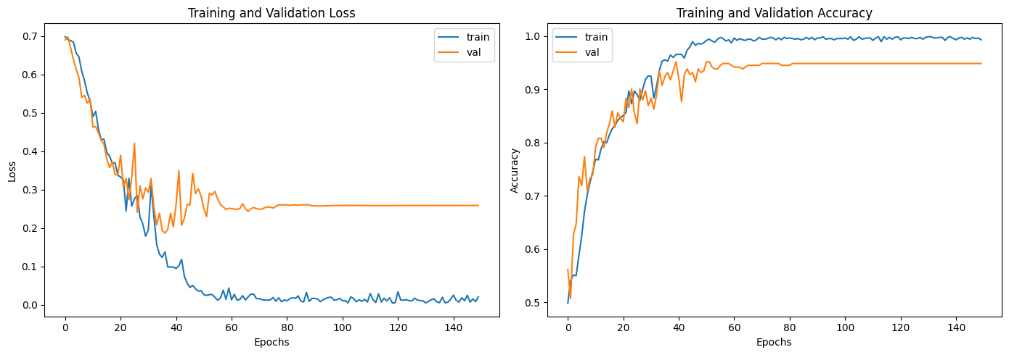

Fig. 10. Training and validation results for the basic CNN-Transformer.

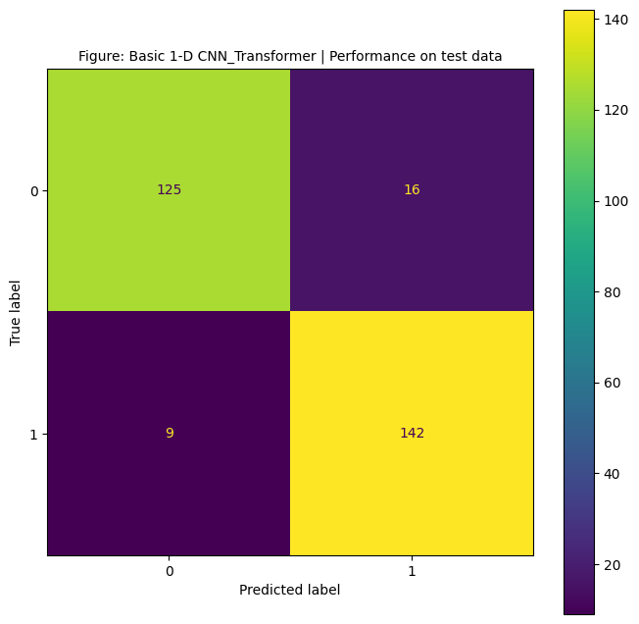

Fig. 11. Confusion matrix for test data using the basic CNN-Transformer.

Table 3. Evaluation metrics for the basic CNN-Transformer on test data.

|  |  |  |  |
| --- | --- | --- | --- |
| Accuracy | Precision | Recall | F1-Score |
|  |  |  |  |

### **. TPE Optimization for CNN-LSTM and CNN-Transformer**

This study employs Optuna’s TPESampler, a Bayesian optimization algorithm, to fine-tune the hyperparameters of the CNN-LSTM model for bridge defect detection. In each trial, combinations of optimizer type, convolutional feature dimensions (num_features_1 and num_features_2), batch size, and learning rate are sampled to construct and train the model. The dataset is split into training, validation, and test sets (60/20/20), and data loaders are generated accordingly. Early stopping is applied during training to prevent overfitting, and the best-performing model from each trial is saved with its test loader included in the checkpoint for later evaluation. The minimum validation loss is returned to guide the optimization process in identifying the most effective hyperparameter configuration. The performance of the tuned CNN-LSTM model is shown in Fig. 12 and Table 4.

Additionally, Optuna’s TPESampler is applied to identify the most informative sensor node combinations for bridge defect detection. In each trial, eight nodes are selected from a pool of 27, prioritizing unvisited nodes to ensure minimal repetition across iterations. These nodes are used to construct a tailored dataset, which is then split into training, validation, and test sets. A pre-optimized CNN-Transformer model (with hyperparameters previously tuned by TPESampler) is trained using data from the selected nodes. The model is trained with early stopping, and the best-performing model is saved, including the selected nodes and the test loader in the checkpoint. The function returns the final validation loss, enabling the optimization process to identify node combinations that yield the most accurate and generalizable model performance. The optimal node selection was [18, 23, 14, 27, 1, 4, 3, 5]. Results are shown in Fig. 13 and Table 5.

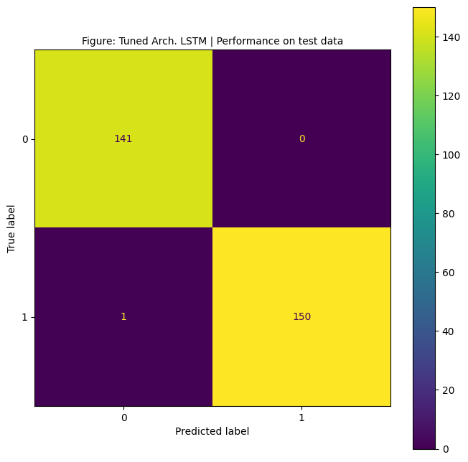

Fig. 12. Confusion matrix for the Tuned CNN-LSTM on test data.

Table 4. Evaluation metrics for the Tuned CNN-LSTM on test data.

|  |  |  |  |
| --- | --- | --- | --- |
| Accuracy | Precision | Recall | F1-Score |
|  |  |  |  |

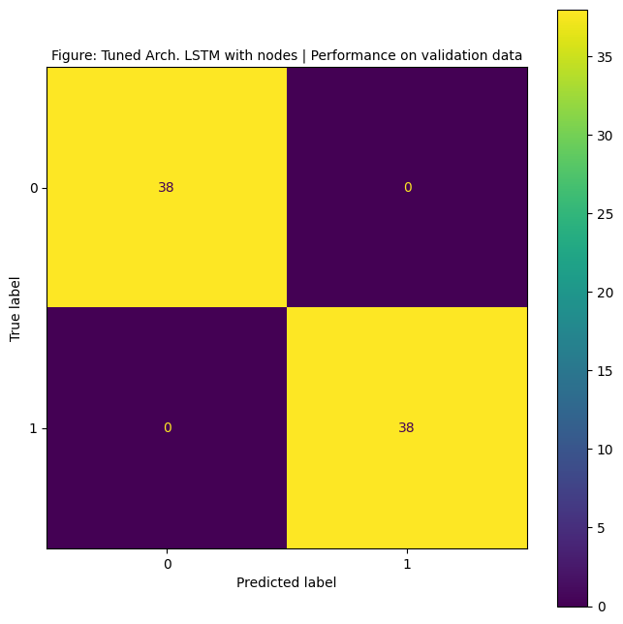

Fig. 13. Confusion matrix for the Tuned CNN-LSTM using the best selected nodes

Table 5. Evaluation metrics for the Tuned CNN-LSTM using selected nodes.

|  |  |  |  |
| --- | --- | --- | --- |
| Accuracy | Precision | Recall | F1-Score |
|  |  |  |  |

Furthermore, the TPESampler is used to optimize the CNN-Transformer model by sampling hyperparameters such as optimizer type, number of transformer layers, attention heads, feature dimensions, batch size, and learning rate. The dataset is split into training, validation, and test sets (60/20/20), and the model is trained using the sampled parameters with early stopping. The best-performing model is saved, with the test loader included in the checkpoint. The optimization process is guided by the minimum validation loss, allowing for iterative refinement of the model configuration. The tuned model’s performance is shown in Fig. 14 and Table 6.

The TPESampler is again used to identify the most informative sensor nodes for this model. In each trial, eight out of 27 nodes are selected, with a focus on minimal repetition. These selected nodes are used to construct the dataset and train the optimized CNN-Transformer model. The best-performing model is saved along with the selected nodes and the test loader. The optimal node selection was [25, 6, 18, 17, 1, 20, 11, 16]. Results are shown in Fig. 15 and Table 7.

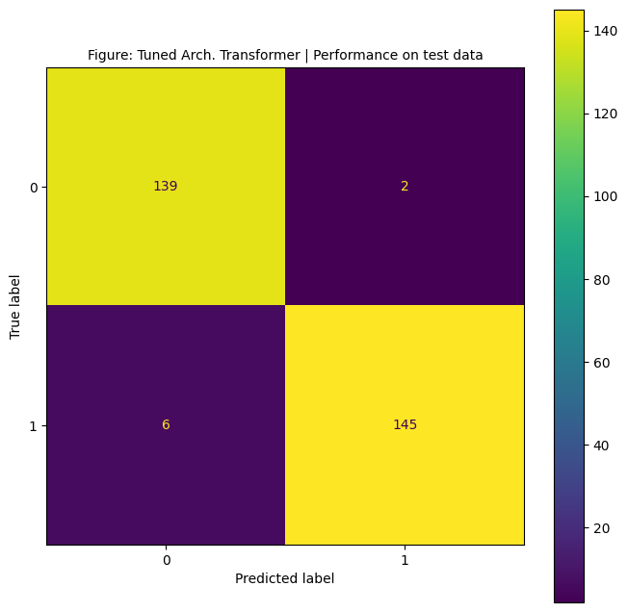

Fig. 14. Confusion matrix for the Tuned CNN-Transformer on test data.

Table 6. Evaluation metrics for the Tuned CNN-Transformer on test data.

|  |  |  |  |
| --- | --- | --- | --- |
| Accuracy | Precision | Recall | F1-Score |
|  |  |  |  |

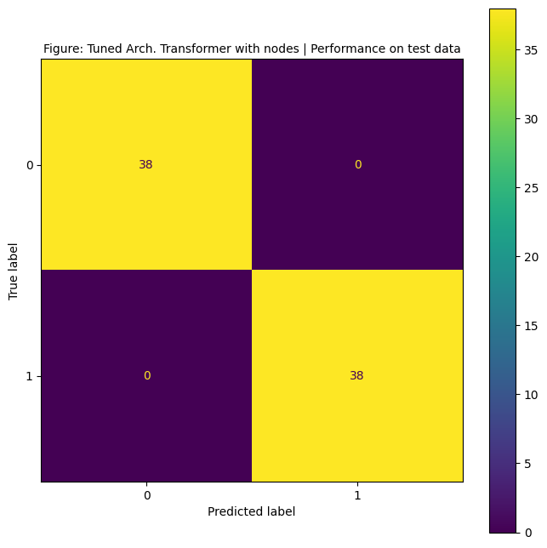

Fig. 15. Confusion matrix for the Tuned CNN-Transformer using the best selected nodes.

Table 7. Evaluation metrics for the Tuned CNN-Transformer using selected nodes.

|  |  |  |  |
| --- | --- | --- | --- |
| Accuracy | Precision | Recall | F1-Score |
|  |  |  |  |

## Chapter 5: Conclusion

(Insert contents)

## References

1. Cha, Y. J., Ali, R., Lewis, J., & Büyükӧztürk, O. (2024). Deep learning-based structural health monitoring. *Automation in Construction*, *161*, 105328.
2. Tuegel, E. (2012, April). The airframe digital twin: some challenges to realization. In *53rd AIAA/ASME/ASCE/AHS/ASC structures, structural dynamics and materials conference 20th AIAA/ASME/AHS adaptive structures conference 14th AIAA* (p. 1812).
3. Grieves, M., & Vickers, J. (2017). Digital twin: Mitigating unpredictable, undesirable emergent behavior in complex systems. *Transdisciplinary perspectives on complex systems: New findings and approaches*, 85-113.
4. Niederer, S. A., Sacks, M. S., Girolami, M., & Willcox, K. (2021). Scaling digital twins from the artisanal to the industrial. *Nature Computational Science*, *1*(5), 313-320.
5. Ye, Y., Yang, Q., Yang, F., Huo, Y., & Meng, S. (2020). Digital twin for the structural health management of reusable spacecraft: a case study. *Engineering Fracture Mechanics*, *234*, 107076.
6. Podskarbi, M., & Knezevic, D. J. (2020, May). Digital twin for operations-present applications and future digital thread. In *Offshore Technology Conference* (p. D031S037R006). OTC.
7. Parida, L., & Moharana, S. (2023). A comprehensive review on piezo impedance based multi sensing technique. *Results in Engineering*, *18*, 101093.
8. Sun, Z., Chen, T., Meng, X., Bao, Y., Hu, L., & Zhao, R. (2023). A critical review for trustworthy and explainable structural health monitoring and risk prognosis of bridges with human-in-the-loop. *Sustainability*, *15*(8), 6389.
9. Bao, Y., Chen, Z., Wei, S., Xu, Y., Tang, Z., & Li, H. (2019). The state of the art of data science and engineering in structural health monitoring. *Engineering*, *5*(2), 234-242.
10. Teng, S., Chen, X., Chen, G., & Cheng, L. (2023). Structural damage detection based on transfer learning strategy using digital twins of bridges. *Mechanical Systems and Signal Processing*, *191*, 110160.
11. Liu, C., Xu, X., Wu, J., Zhu, H., & Wang, C. (2023). Deep transfer learning-based damage detection of composite structures by fusing monitoring data with physical mechanism. *Engineering Applications of Artificial Intelligence*, *123*, 106245.
12. Tavana, N. R., & Dinavahi, V. (2016). Real-time nonlinear magnetic equivalent circuit model of induction machine on FPGA for hardware-in-the-loop simulation. *IEEE Transactions on Energy Conversion*, *31*(2), 520-530.
13. Abdeljaber, O., Avci, O., Kiranyaz, S., Gabbouj, M., & Inman, D. J. (2017). Real-time vibration-based structural damage detection using one-dimensional convolutional neural networks. *Journal of sound and vibration*, *388*, 154-170.
14. Avci, O., Abdeljaber, O., Kiranyaz, S., Hussein, M., & Inman, D. J. (2018). Wireless and real-time structural damage detection: A novel decentralized method for wireless sensor networks. *Journal of Sound and Vibration*, *424*, 158-172.
15. Abdeljaber, O., Avci, O., Kiranyaz, M. S., Boashash, B., Sodano, H., & Inman, D. J. (2018). 1-D CNNs for structural damage detection: Verification on a structural health monitoring benchmark data. *Neurocomputing*, *275*, 1308-1317.
16. Lin, Y. Z., Nie, Z. H., & Ma, H. W. (2017). Structural damage detection with automatic feature‐extraction through deep learning. *Computer‐Aided Civil and Infrastructure Engineering*, *32*(12), 1025-1046.
17. Wang, Z., & Cha, Y. J. (2018, March). Automated damage-sensitive feature extraction using unsupervised convolutional neural networks. In *Sensors and Smart Structures Technologies for Civil, Mechanical, and Aerospace Systems 2018* (Vol. 10598, pp. 380-386). SPIE.
18. Zhang, T., Biswal, S., & Wang, Y. (2020). SHMnet: Condition assessment of bolted connection with beyond human-level performance. *Structural Health Monitoring*, *19*(4), 1188-1201.
19. Gopalakrishnan, S., Ruzzene, M., Hanagud, S., Gopalakrishnan, S., Ruzzene, M., & Hanagud, S. (2011). Application of the finite element method in shm. *Computational Techniques for Structural Health Monitoring*, 157-175.
20. Dado, M. H., & Shpli, O. A. (2003). Crack parameter estimation in structures using finite element modeling. *International Journal of solids and structures*, *40*(20), 5389-5406.
21. Ghoshal, A., Kim, H. S., Kim, J., Choi, S. B., Prosser, W. H., & Tai, H. (2006). Modeling delamination in composite structures by incorporating the Fermi–Dirac distribution function and hybrid damage indicators. *Finite elements in analysis and design*, *42*(8-9), 715-725.
22. Pawar, P. M., & Ganguli, R. (2005). On the effect of matrix cracks in composite helicopter rotor blade. *Composites Science and Technology*, *65*(3-4), 581-594.
23. Yang, C., Ye, L., Su, Z., & Bannister, M. (2006). Some aspects of numerical simulation for Lamb wave propagation in composite laminates. *Composite structures*, *75*(1-4), 267-275.
24. Ewald, V., Groves, R. M., & Benedictus, R. (2019, March). DeepSHM: A deep learning approach for structural health monitoring based on guided Lamb wave technique. In *Sensors and Smart Structures Technologies for Civil, Mechanical, and Aerospace Systems 2019* (Vol. 10970, pp. 84-99). SPIE.
25. Rizzo, P., Cammarata, M., Bartoli, I., Di Scalea, F. L., Salamone, S., Coccia, S., & Phillips, R. (2010). Ultrasonic guided waves‐based monitoring of rail head: laboratory and field tests. *Advances in civil engineering*, *2010*(1), 291293.
26. Miao, L., Gao, B., Li, H., Lu, X., Liu, L., Woo, W. L., & Wu, J. (2023). Novel interventional electromagnetic thermography for subsurface defect detection. *International Journal of Thermal Sciences*, *184*, 107960.
27. Ali, R., & Cha, Y. J. (2019). Subsurface damage detection of a steel bridge using deep learning and uncooled micro-bolometer. *Construction and Building Materials*, *226*, 376-387.
28. Arbaoui, A., Ouahabi, A., Jacques, S., & Hamiane, M. (2021). Concrete cracks detection and monitoring using deep learning-based multiresolution analysis. *Electronics*, *10*(15), 1772.
29. Han, G., Kim, Y. M., Kim, H., Oh, T. M., Song, K. I., Kim, A., ... & Kwon, T. H. (2021). Auto-detection of acoustic emission signals from cracking of concrete structures using convolutional neural networks: Upscaling from specimen. *Expert Systems with Applications*, *186*, 115863.
30. Kiranyaz, S., Ince, T., Hamila, R., & Gabbouj, M. (2015, August). Convolutional neural networks for patient-specific ECG classification. In *2015 37th Annual International Conference of the IEEE Engineering in Medicine and Biology Society (EMBC)* (pp. 2608-2611). IEEE.
31. Kiranyaz, S., Avci, O., Abdeljaber, O., Ince, T., Gabbouj, M., & Inman, D. J. (2021). 1D convolutional neural networks and applications: A survey. *Mechanical systems and signal processing*, *151*, 107398.
32. Serghini, O., Semlali, H., Maali, A., Ghammaz, A., & Serrano, S. (2023). 1-D Convolutional Neural Network-Based Models for Cooperative Spectrum Sensing. *Future Internet*, *16*(1), 14.
33. Lin, Y. Z., Nie, Z. H., & Ma, H. W. (2017). Structural damage detection with automatic feature‐extraction through deep learning. *Computer‐Aided Civil and Infrastructure Engineering*, *32*(12), 1025-1046.
34. Vaswani, A., Shazeer, N., Parmar, N., Uszkoreit, J., Jones, L., Gomez, A. N., ... & Polosukhin, I. (2017). Attention is all you need. *Advances in neural information processing systems*, *30*.
35. Jia, J., & Li, Y. (2023). Deep learning for structural health monitoring: Data, algorithms, applications, challenges, and trends. *Sensors*, *23*(21), 8824.
36. Rosso, M. M., Cucuzza, R., Marano, G. C., Aloisio, A., & Cirrincione, G. (2022). Review on deep learning in structural health monitoring. In *Bridge Safety, Maintenance, Management, Life-Cycle, Resilience and Sustainability* (pp. 309-315). CRC Press.
37. Dang, H. V., Tran-Ngoc, H., Nguyen, T. V., Bui-Tien, T., De Roeck, G., & Nguyen, H. X. (2020). Data-driven structural health monitoring using feature fusion and hybrid deep learning. *IEEE Transactions on Automation Science and Engineering*, *18*(4), 2087-2103.
38. Fang, X., Li, H., Zhang, S. R., Wang, X. H., Wang, C., & Luo, X. C. (2023). A combined finite element and deep learning network for structural dynamic response estimation on concrete gravity dam subjected to blast loads. *Defence Technology*, *24*, 298-313.
39. Pathirage, C. S. N., Li, J., Li, L., Hao, H., Liu, W., & Ni, P. (2018). Structural damage identification based on autoencoder neural networks and deep learning. *Engineering structures*, *172*, 13-28.
40. Hashemi, A., Jang, J., & Beheshti, J. (2023). A machine learning-based surrogate finite element model for estimating dynamic response of mechanical systems. *IEEE Access*, *11*, 54509-54525.
41. Kosova, F., Altay, Ö., & Ünver, H. Ö. (2024). Structural health monitoring in aviation: a comprehensive review and future directions for machine learning. *Nondestructive Testing and Evaluation*, 1-60.
42. Capozzoli, L., & Rizzo, E. (2017). Combined NDT techniques in civil engineering applications: Laboratory and real test. *Construction and Building Materials*, *154*, 1139-1150.
43. Rhazi, J. (2000). NDT in civil engineering: The case of concrete bridge decks. *CSNDT JOURNAL*, *21*(5), 18-25.
44. McCann, D. M., & Forde, M. C. (2001). Review of NDT methods in the assessment of concrete and masonry structures. *Ndt & E International*, *34*(2), 71-84.
45. Wiggenhauser, H., & Taffe, A. (2012, April). NDT in civil engineering: research, application, validation and training. In *18th World Conference on Nondestructive Testing*.
46. Foucher, F., Fernandez, R., Algernon, D., Leberre, S., Leymarie, N., & Dorval, V. (2022, August). Application of simulation software for NDT for civil engineering. In *NDT-CE 2022-The International Symposium on Nondestructive Testing in Civil Engineering* (Vol. 27, No. 9).
47. Nguyen, D. C., Salamak, M., Katunin, A., Poprawa, G., & Gerges, M. (2024). Vibration-based SHM of railway steel arch bridge with orbit-shaped image and wavelet-integrated CNN classification. *Engineering Structures*, *315*, 118431.
48. Avci, O., Abdeljaber, O., Kiranyaz, S., & Inman, D. (2017). Structural damage detection in real time: implementation of 1D convolutional neural networks for SHM applications. In *Structural Health Monitoring & Damage Detection, Volume 7: Proceedings of the 35th IMAC, A Conference and Exposition on Structural Dynamics 2017* (pp. 49-54). Springer International Publishing.
49. Duan, Y., Chen, Q., Zhang, H., Yun, C. B., Wu, S., & Zhu, Q. (2019). CNN-based damage identification method of tied-arch bridge using spatial-spectral information. *Smart Struct. Syst*, *23*(5), 507-520.
50. Zhang, X., & Zhou, W. (2023). Structural Vibration Data Anomaly Detection Based on Multiple Feature Information Using CNN‐LSTM Model. *Structural Control and Health Monitoring*, *2023*(1), 3906180.
51. Huang, L., Hong, X., Yang, Z., Liu, Y., & Zhang, B. (2022). CNN-LSTM network-based damage detection approach for copper pipeline using laser ultrasonic scanning. *Ultrasonics*, *121*, 106685.

## Appendix